**Line integral:**

**P512** Curl and divergence

$\int_{C}^{ }{F∙dr}$, where $r\left(t\right)=x\left(t\right)i+y\left(t\right)j and F\left(x,y\right)=P\left(x,y\right)i+Q(x,y)j$

**P529.** Conservative Vec field: $\frac{∂P}{∂y}=\frac{∂Q}{∂x}$

**P526. If F is a conservative vector field, then we can: $\int_{C}^{ }{F∙dr}=\int_{C}^{ }{∇ϕ∙dr=ϕ\left(B\right)-ϕ(A)}$**

**P528. $\int_{C}^{ }{F∙dr}=0$**

**P521 $Work=\int_{C}^{ }{F∙dr}$**

**P544** Polar Coordinates: (Always add $×r$)

Move to polar if it is a circle or sphere

**P538** Center of Mass for $ρ(x,y)$

**P539** Moment of inertia

**P540** Solid bounded by a plane

**P549** Region with holes

**P553** surface Area:

$$\iint_{R}^{ }{\sqrt{1+{\left[\frac{∂f\left(x,y\right)}{∂x}\right]}^{2}+{\left[\frac{∂f\left(x,y\right)}{∂y}\right]}^{2}dxdy}}$$

If it is a sphere move to polar coordinates

**P554** surface Integral:

$$\iint_{R}^{ }{G\left(x,y,z\right)\sqrt{1+{\left[\frac{∂f\left(x,y\right)}{∂x}\right]}^{2}+{\left[\frac{∂f\left(x,y\right)}{∂y}\right]}^{2}dA}}$$

**P554** Projection of S onto other planes

**P554** Mass of a surface

Important: <https://moodle.concordia.ca/moodle/mod/lti/view.php?id=2228205>

**P556** Flux

For the flux: $n=\frac{1}{\left|∇g\right|}∇g$ where g is the equation of the plane

**P562** stokes theorem :

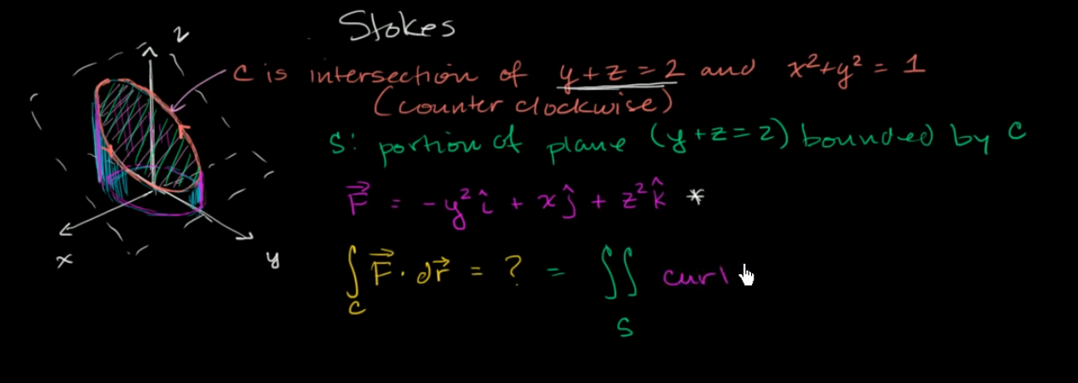

https://www.khanacademy.org/math/multivariable-calculus/greens-theorem-and-stokes-theorem/stokes-theorem/v/stokes-example-part-1

**P566** Center of mass for $ρ(x,y,z)$

**P575** Divergence theorem

**P571** Spherical coordinates of triple integrals

**P587** The rate of fluide passing through a Region D in time t

Calculate Flux <https://moodle.concordia.ca/moodle/mod/lti/view.php?id=2228205>

**P579 15)** Mass of fluide per unit time (with the minus?)